Requirement Analysis: Data Flow Diagrams & User Stories

B) Data Flow Diagram (DFD) and User Stories

Level-0 Data Flow Diagram
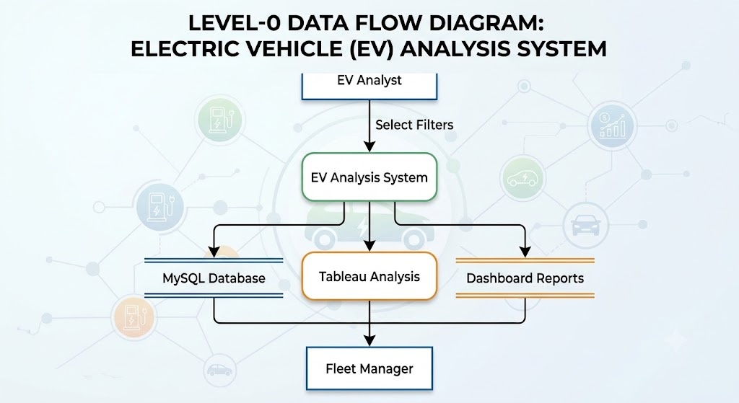

Level-1 Data Flow Diagram
Source CSVs -> Ingest in MySQL -> Data Cleaning (TRIM, DISTINCT) -> Cleaned tables -> Connect to Tableau -> Calculated Fields -> Worksheets -> Dashboard Assembly -> Packaged Workbook (TWBX)

User Stories
User Story 1 - EV Buyer
As an EV Buyer, I want to compare price and range to identify suitable value options.
Acceptance: Range vs Price scatter plot active with zoom controls.
User Story 2 - Fleet Manager
As a Fleet Manager, I want vehicles below their segment-average range flagged.
Acceptance: Underperformer LOD calculated field highlights fleet vehicles.
User Story 3 - Infrastructure Analyst
As an Infrastructure Analyst, I want charger maps filterable by service type.
Acceptance: Geographical map shows charging locations color-coded by speed.

User Story 4 - India EV Buyer
As an Indian EV Buyer, I want to view localized prices and range metrics.
Acceptance: Dedicated EV India worksheet displaying Rupee price curves.
System Data Flow Reference Map
